STARAGILE AWS ASSIGNMENT -2

1. **Sign in to the AWS Management Console:** Log in to your AWS account.

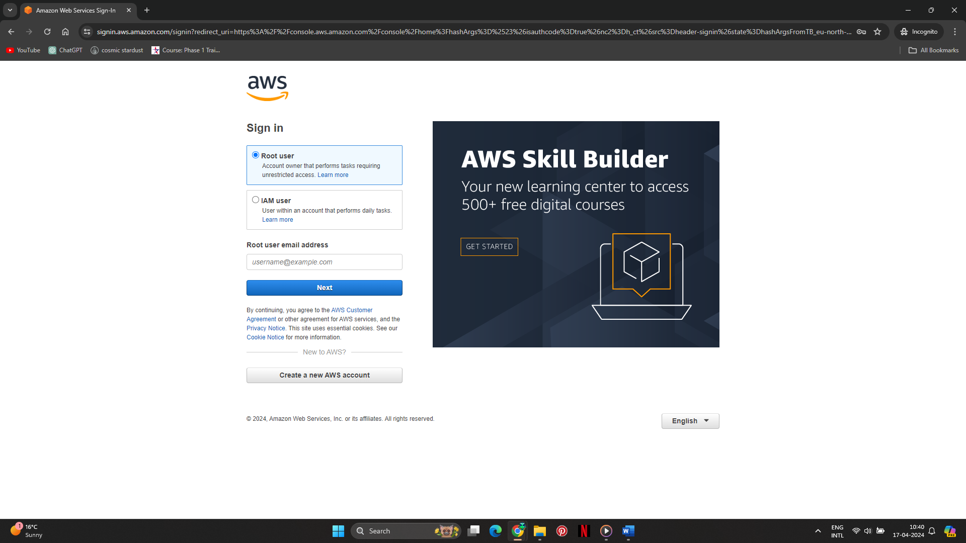

1. **Navigate to EC2:** From the AWS Management Console, go to the EC2 service.

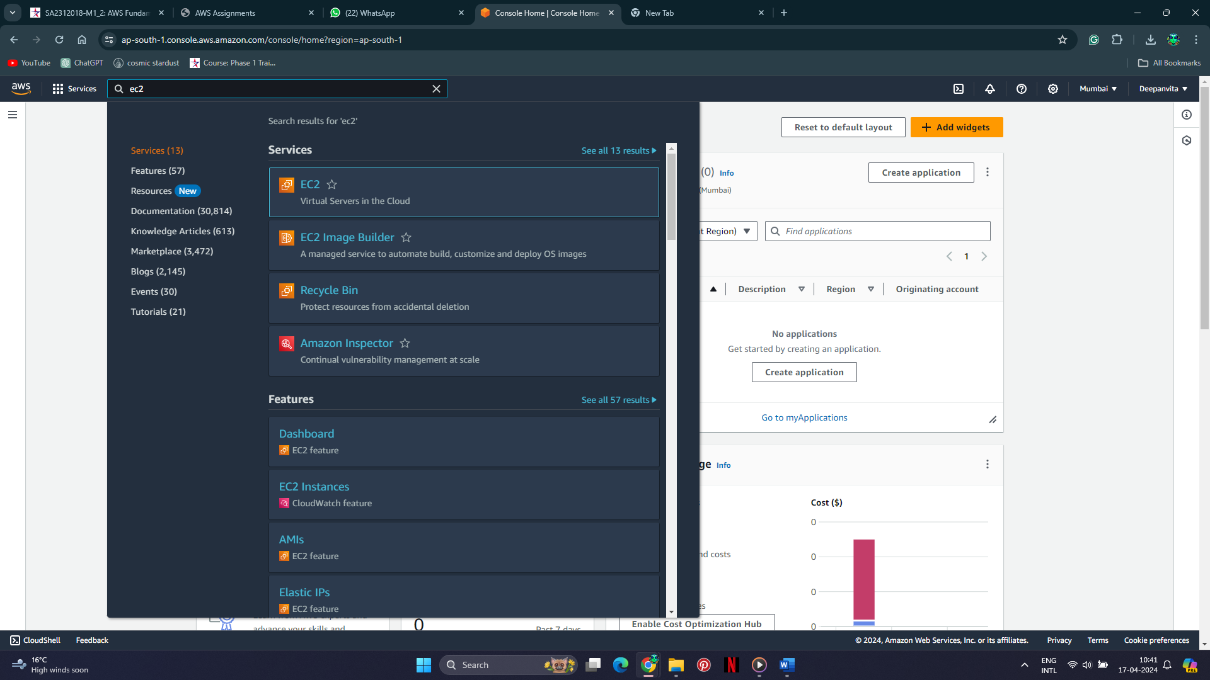

1. **Launch Instance:** Click on the "Launch Instance" button to begin the instance creation process.

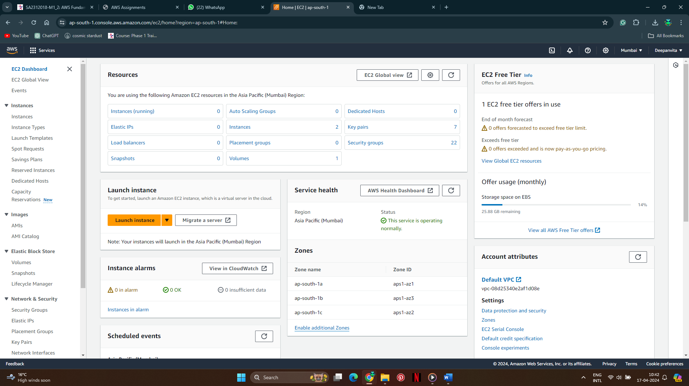

1. **Choose an Amazon Machine Image (AMI):** Select "Ubuntu Server 22.04 LTS" as the AMI for the instance.

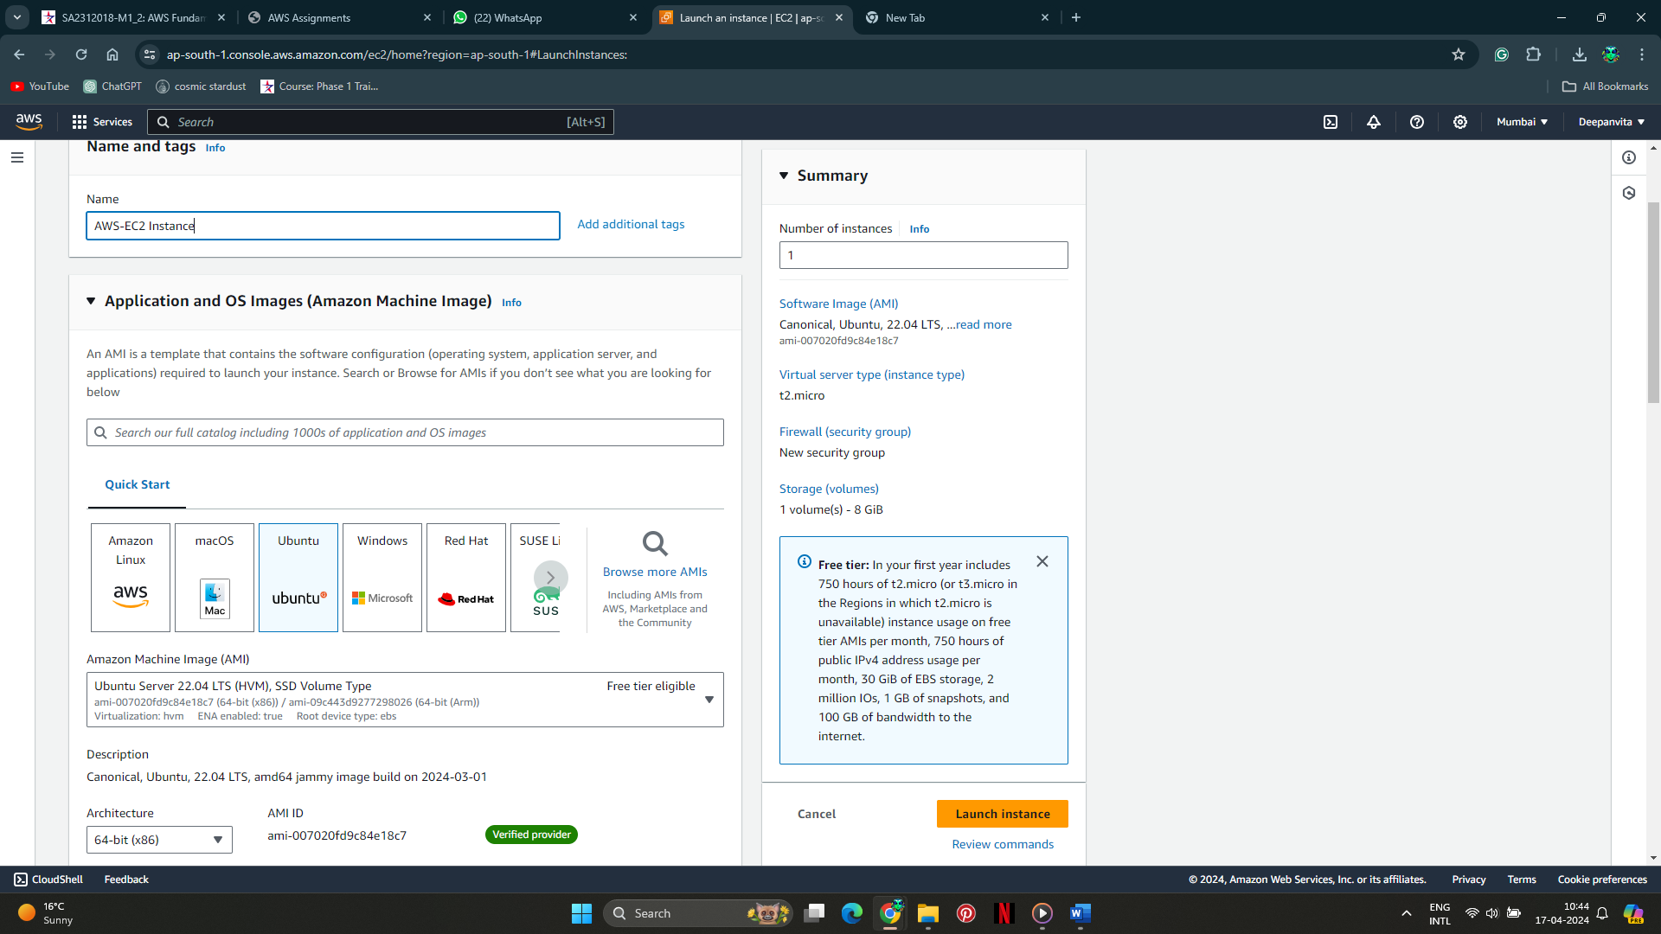

1. **Choose Instance Type:** Select the instance type as "t2.micro" as specified.



1. **Configure Instance:** Proceed with default settings or customize as needed.
2. **Add Storage:** Ensure that the instance has at least 8 GB of General Purpose SSD storage attached.

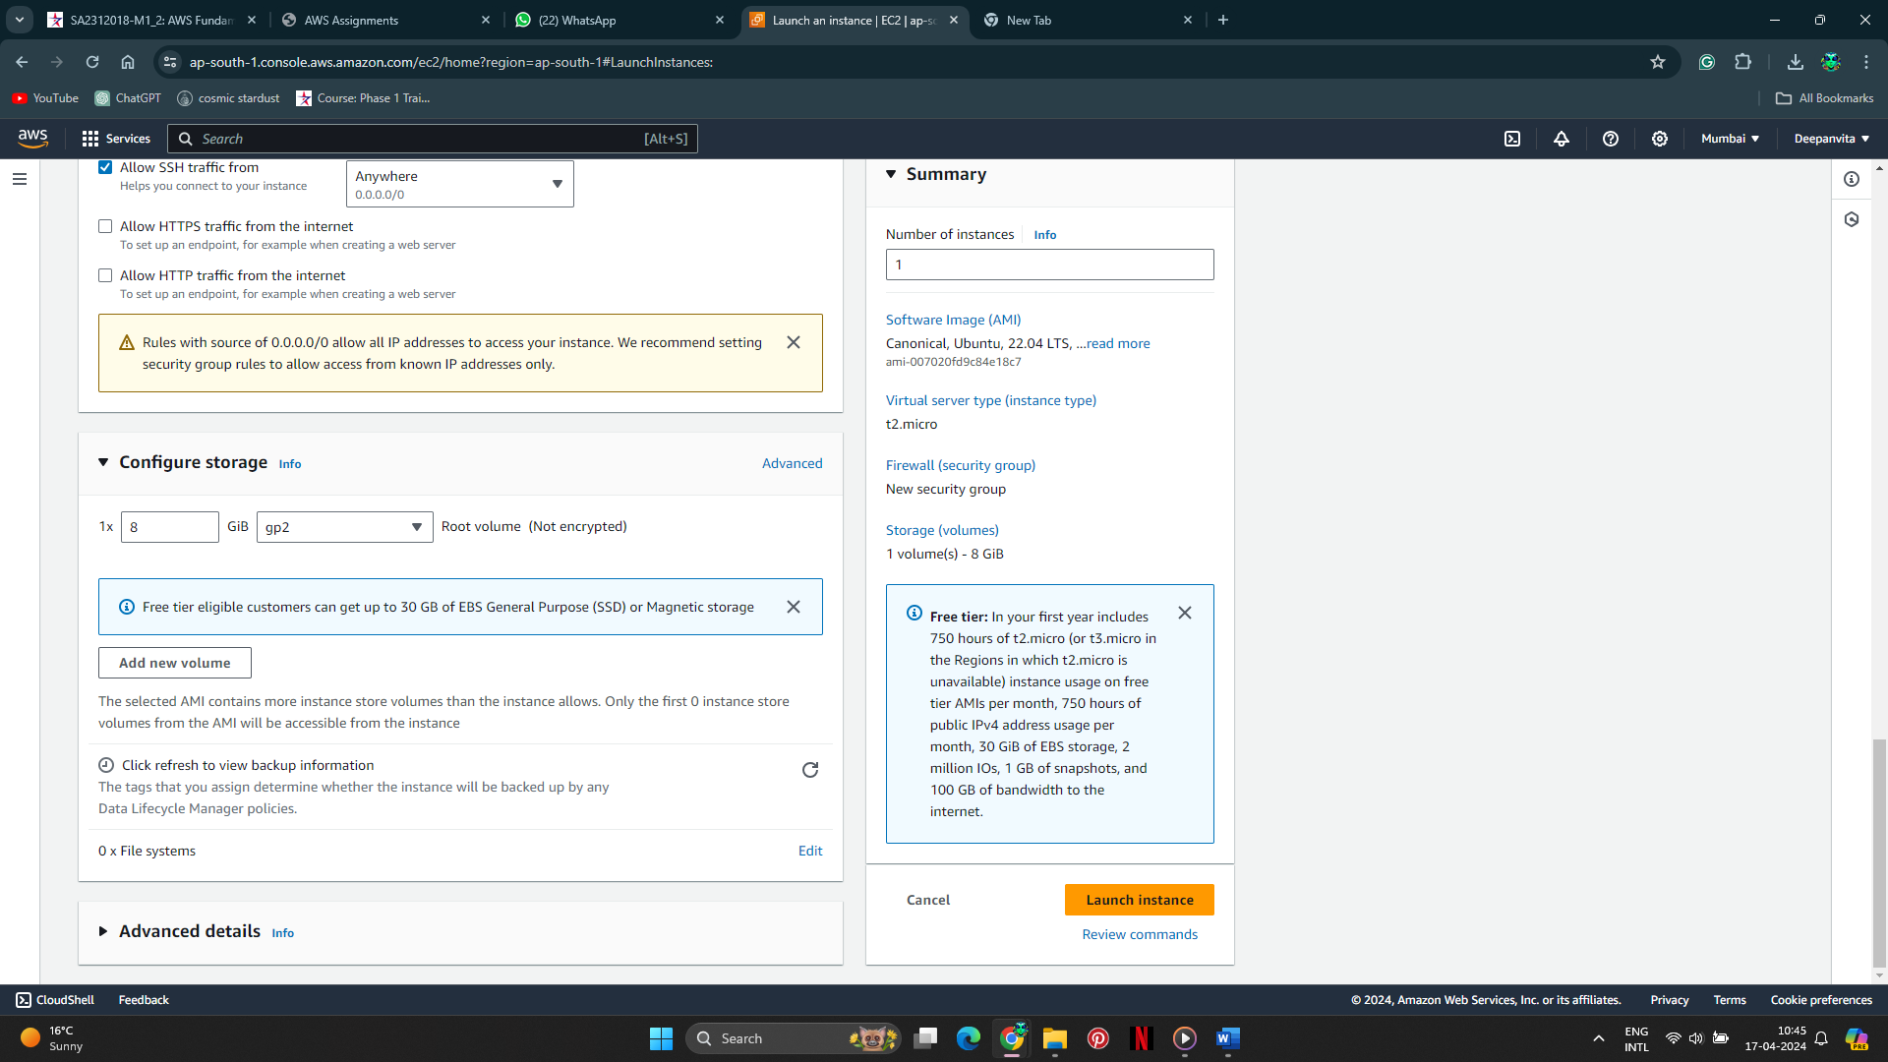

1. **Key pair:** Use the same key pair we created in the previous assignment

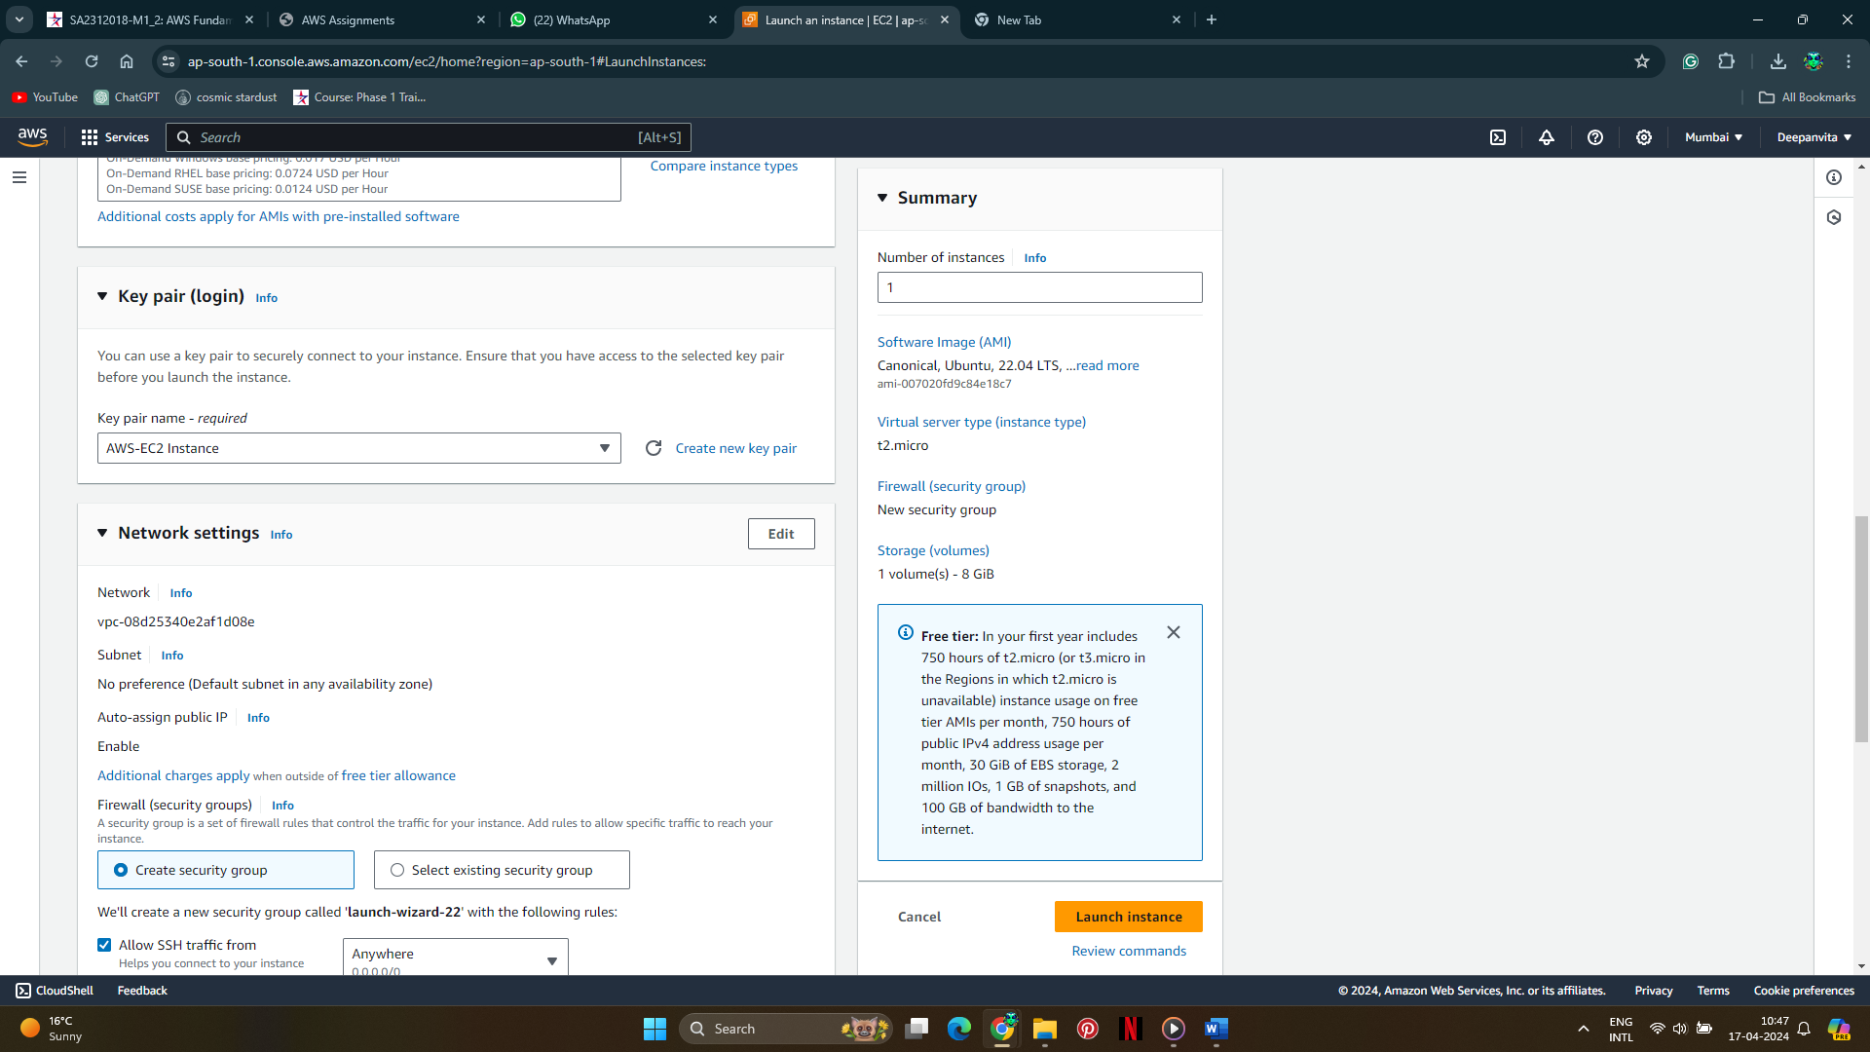

1. **Review Instance Launch:** Review the instance details to ensure they match the requirements.
2. **Launch Instance:** Click on the "Launch" button to launch the instance.
3. **Configure Security Group:** Edit the security group as earlier with the following rules:
   * Rule 1: Type - HTTP, Protocol - TCP, Port Range - 80, Source - Custom, IP Address of the client's machine.

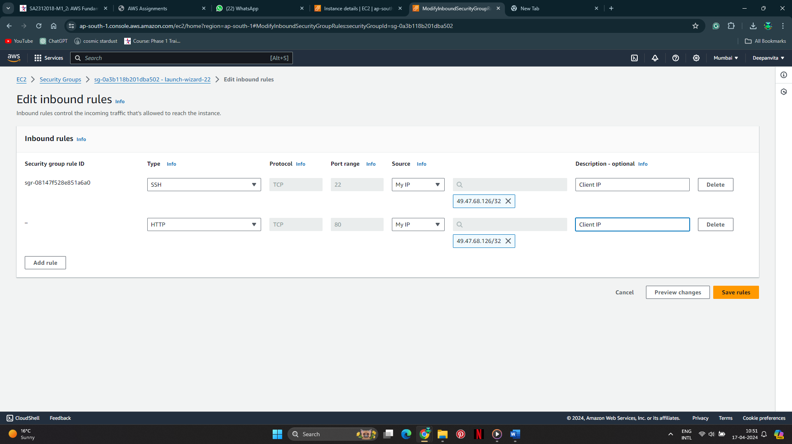

* + Rule 2: Type - SSH, Protocol - TCP, Port Range - 22, Source - Custom, IP Address of the client's machine.



1. Change the instance name

Edit the name.  
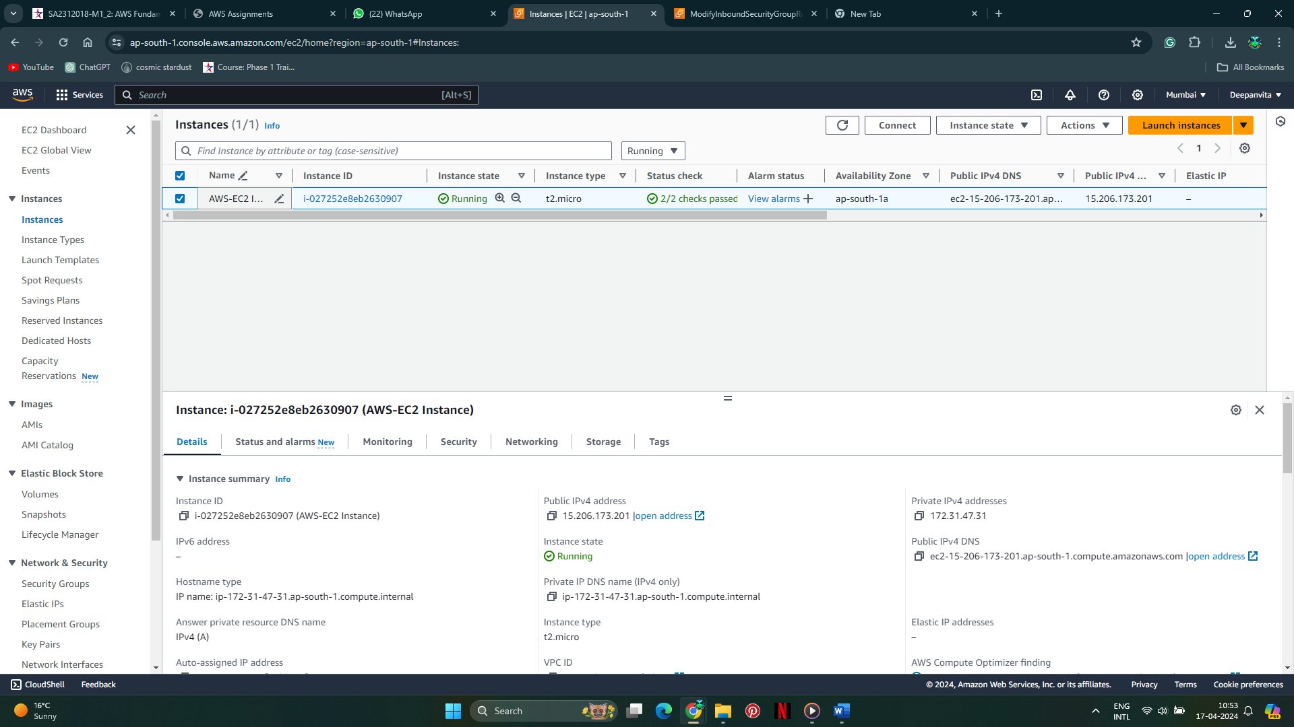

Done.

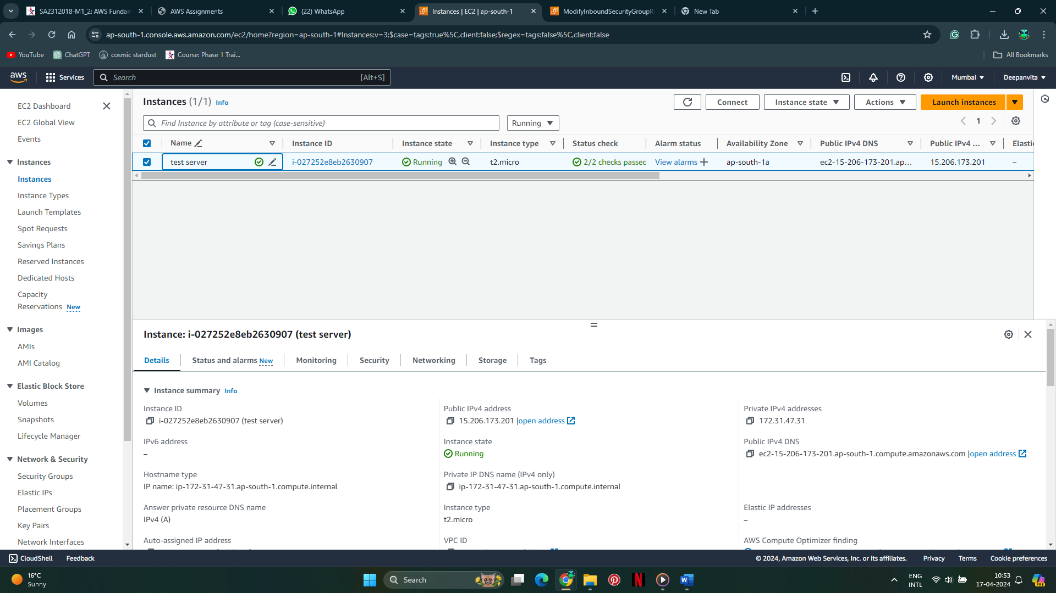

1. SSH into the launched instance
   * 1. Go to the location where your key file is
     2. Open git bash there

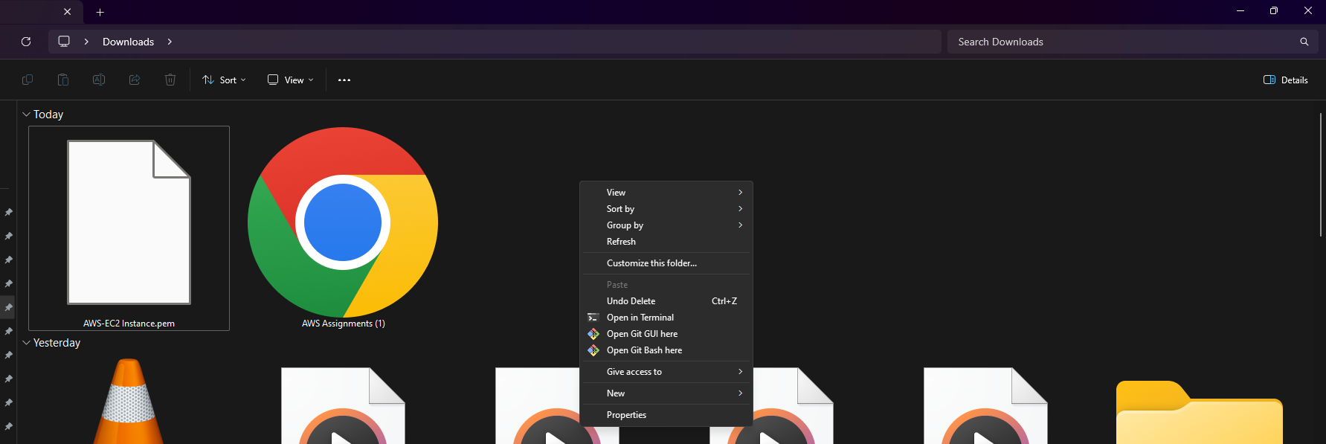

* + 1. Use ssh command as provided in the connect ssh section

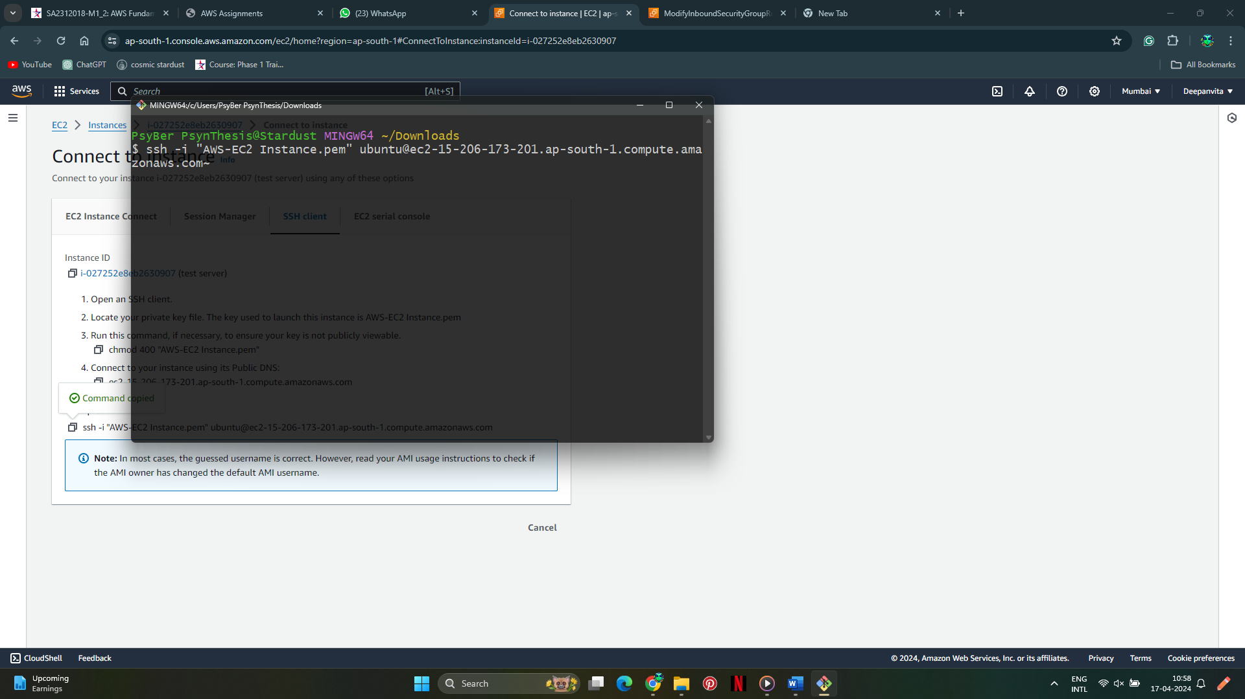

* + 1. Done

